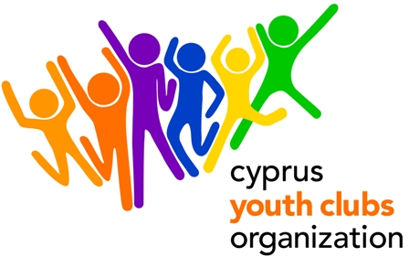
ENGAGE CHANGE
Youth in Action, sub-Action 4.3. Partnership-Building Activity

PROJECT OUTLINE
- Project title: ENGAGE CHANGE
- Organization: Cyprus Youth Clubs Organization (CYCO)
- Main theme for the project: promoting exchanges, cooperation and training in the field of youth work.
- We encourage organizations to participate with 2 people each.
- Project type: Youth in Action, 4.3, Partnership-Building Activity
- (Action 4 - Youth Support Systems/ Sub-Action 4.3 – Training and networking of those active in youth work and youth organizations). Partnership Building Activity.
- Organizations’ Country: Cyprus
- Place: Cyprus
- The project starts: 1 March 2011 (arrival date)
- The project ends: 7 March 2011 (half day activities/ half day departures)
- Deadline for applications: July 26
- Duration: 7 days with the travelling days
- Group age (average): none
- Contact person: Dalosi Anna
- E-mail: adalosi@cyco.org.cy
- Tel.: +35722323260
- Fax: +35722321979
- Summary of the project: Young people and Youth workers will exchange ways to empower youth in rural areas to participate in their organizations and their communities. Enhancement of young people’s skills and attributes is seen as a major way in developing the capacity of youth organizations in rural areas. We will develop methods to engage young people in Youth Organizations and to enforce them to lead change. Ways to promote young people’s active citizenship will be explored. Intercultural learning will take place at all stages of the activity. Participants will share their experiences, present successful methods and form new tools for addressing the project’s objectives.
- Financial aspects: participants will be reimbursed for the 70% of the travel cost on display of their boarding passes. Food and accommodation is paid. Participants will be required to pay a participation fee of €30.
- Safety & Insurance: We will require copies of the travel insurances before travelling to Cyprus.
- How to participate: Send us a short description of your organization and the link to you website (if available). After you fill in the Part 3 (make sure it is the 2010 version), fax it to +357 22321979 or send the scanned version to Anna Dalosi adalosi@cyco.org.cy and mail the original to:
ANNA DALOSI
CYPRUS YOUTH CLUBS ORGANIZATION
Platia Iroon 1, Ag. Mamas, Lakatamia, 2330, CUPRUS

